Eclipse Configuration for OpenCDS, Drools, and GreenCDA

Last modified 2010-09-10 by David Shields

Eclipse Configuration for OpenCDS, Drools, and GreenCDA 1
I. Shortcut Instructions (using existing zip file of Eclipse folder) 4
A. Unzip Eclipse contents under C:\Program Files 4
B. Modify C:\Program Files\eclipse\eclipse.ini so points to appropriate JDK 4
C. Use Tortoise SVN to export projects to C:\WorkJava 4
D. Use Eclipse import wizard to import projects as Maven projects 4
E. Right Click on each project → Team → Share Project → SVN 4
1. URL: https://cfmdcisrv03.dhe.duke.edu/svn/CFMDCI 4
2. project] → OK → Next → Finish 4
F. Right Click on each project → Debug as 4
1. Maven Clean 4
2. Maven Install 4
G. Right click on server project → Debug as → Debug on Server 5
II. Basic Eclipse Configuration 6
A. Dependencies – Install first 7
1. Install Java 7
2. Install Maven 7
3. Install TortoiseSVN 7
4. Install Tomcat 6 (Most of you already have it installed.) 9
B. Install Eclipse, latest stable version 9
1. http://www.eclipse.org/downloads/ 9
2. Choose 32 or 64 bit version 10
3. Install Eclipse Plugins 10
4. Make sure Eclipse is pointed to a JDK rather than a JRE in Eclipse Preferences 13
5. Set Eclipse Preferences for Subversion 14
6. Set up Server in Eclipse 14
7. Set Eclipse to use JDK instead of JRE 14
8. Set Eclipse Preferences for Maven 15
9. Setup Eclipse Servers 18
III. OpenCDS Configuration in Eclipse 20
A. Import into Eclipse 20
1. Export the package from Subversion into C:\WorkJava (see below for alternate instructions using Eclipse directly, not Tortoise SVN) 20
2. Export the package from Subversion into C:\Workjava using Eclipse (alternate instructions from above) 23
3. Import the project from C:\workJava into Eclipse 26
IV. Drools Configuration in Eclipse (coming) 30
A. Import into Eclipse 30
V. GreenCDA Mapper Configuration in Eclipse (coming) 30
A. Dependencies – Install first 30
1. Eclipse modeling tools 30
B. Install GreenCDA 30
1. Follow directions 30
2. Install CDA model 30
3. Install Sample Maps 30

Shortcut Instructions (using existing zip file of Eclipse folder)

Unzip Eclipse contents under C:\Program Files

Modify C:\Program Files\eclipse\eclipse.ini so points to appropriate JDK

Use Tortoise SVN to export projects to C:\WorkJava

Use Eclipse import wizard to import projects as Maven projects

Right Click on each project → Team → Share Project → SVN

URL: https://cfmdcisrv03.dhe.duke.edu/svn/CFMDCI

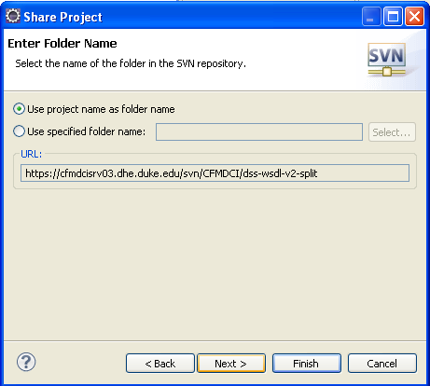project] → OK → Next → Finish

Right Click on each project → Debug as

Maven Clean

Maven Install

Right click on server project → Debug as → Debug on Server

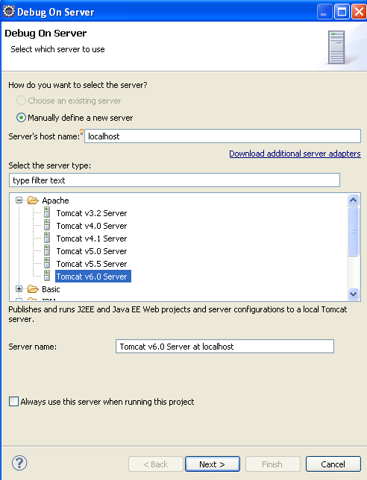

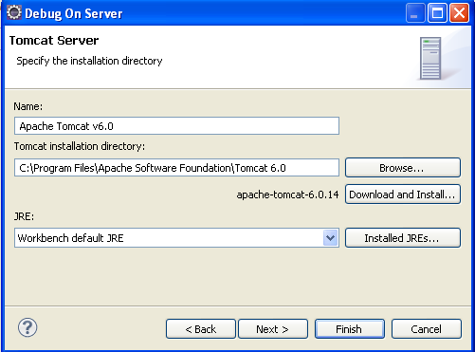

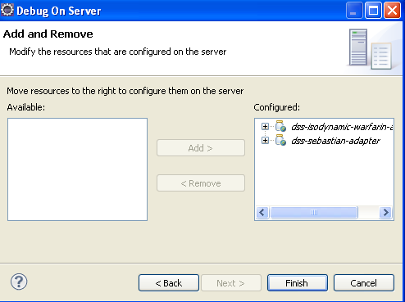

Basic Eclipse Configuration

Dependencies – Install first

Install Java

At least 1.5 JRE to run Eclipse

At least 1.6 JDK for Duke development stuff

Install Maven

http://maven.apache.org/download.html

unzip into c:\EclipseInstallFiles

install into C:\Program Files\Apache Software Foundation\apache-maven-2.2.1
Follow instructions in README.txt to set paths.
I set MAVEN_HOME to “C:\Program Files\Apache Software Foundation\apache-maven-2.2.1”
I then added %MAVEN_HOME%\bin to my Path. This allows me to use %MAVEN_HOME% in scripts, without having to specify (or remember) the entire path
Test it by by typing into a command prompt mvn –version (note there are two dashes before “version”) and it should show something similar to this:
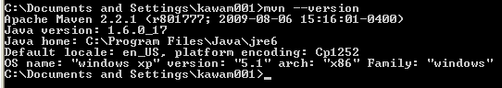
A PDF manual for Maven is available for download, a copy is stored at the same place as this document.

Duke Maven repository is at http://cfmdcisrv03.dhe.duke.edu:8081/nexus/content/groups/public

The installation of m2eclipse will have created a local repository, such as “C:\Documents and Settings\ds187\.m2\repository”

Install TortoiseSVN
This is optional but helpful. There are also other open-source Subversion clients available, but we like TortoiseSVN. You may be able to get by with just the Eclipse plug-in for Subversion if you know what you are doing…

http://tortoisesvn.net/downloads
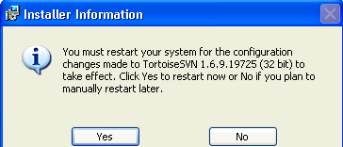
Choose 32 or 64 bit
Choose language
Install
Follow wizard and it should finish like this
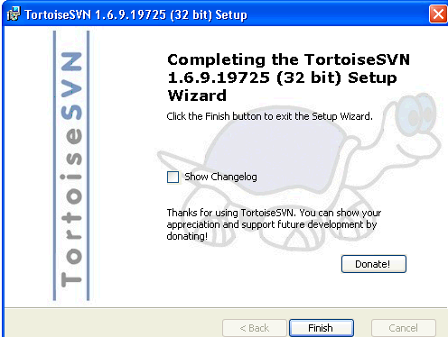
Right click on a folder in windows explorer and create your Subversion settings
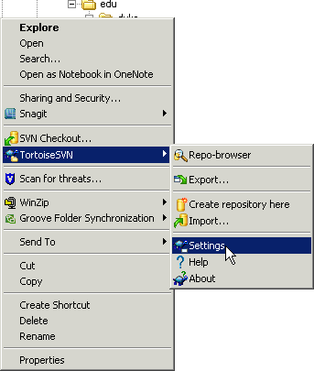

You should probably restart now (but I am going to do it later)
Instructions for the use of TortoiseSVN are found below under “OpenCDS Configuration in Eclipse”

Install Tomcat 6 (Most of you already have it installed.)

http://tomcat.apache.org/download-60.cgi
Accept defaults
One caveat: Install it at C:\Program Files\Apache Software Foundation\Tomcat 6.0 to be compatible with other Duke uses of Tomcat, many of which have hard-coded paths to that location.
Make sure CATALINA_HOME is in your environment
Make sure %CATALINA_HOME%\bin is in your path

Install Eclipse, latest stable version

http://www.eclipse.org/downloads/

Choose 32 or 64 bit version
You can probably get by with a smaller version (e.g., Eclipse IDE for Java Developers) if you are short on disk space, but the EE version has some useful stuff for web services
This download will take some time – it is huge (20 min +/-). You might want to try an alternate mirror if it is too slow
Unzip it directly into c:\Program Files where it will create a directory named Eclipse. This will also take some time (20 min +/-), so be patient
You do not need to modify your path or add environment variables to use eclipse
You may want to add a shortcut for it on your quick-start bar, or in your start menu. You may also want to give it more memory to work with (see eclipse help)
Read the release notes (especially if you have problems) found at C:\Program Files\eclipse\readme\readme_eclipse.html
Remember that you can often fix weird problems in eclipse from a command prompt by entering “eclipse –clean” which will start eclipse with a clean slate

Install Eclipse Plugins
Eclipse has built-in tools to locate and install plug-ins, and to update them when necessary. Use the built-in tools whenever possible. See Eclipse help text
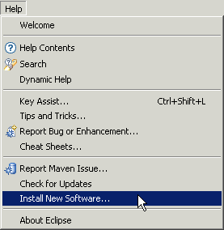

M2Eclipse

http://m2eclipse.sonatype.org/

PDF manual available for download, a copy is stored at the same place as this file.

From Eclipse / Help, select Install New Software
An Install window will open
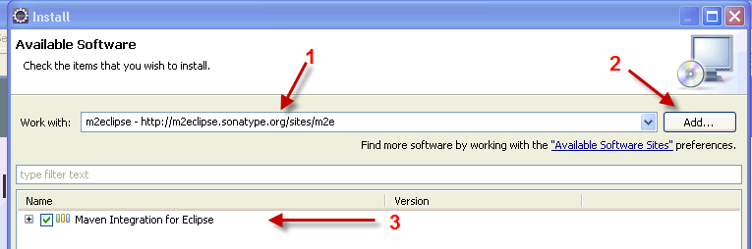
Type the name and URL (1) after clicking the Add button (2), and you should then click in the box beside “Maven Integration for Eclipse (3), and click the Next button at the bottom of the Install window.
It will verify your selection (making sure dependencies are present), and then give you a chance to go back to add dependencies, or continue by clicking Next.
Accept the license and click Finish
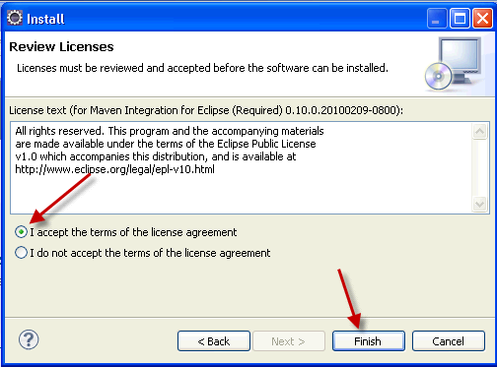
Click OK to ignore the warning, if you get one.
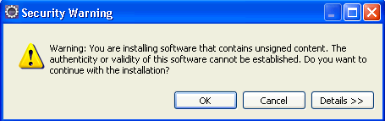

Subclipse
- Help → Eclipse Marketplace
- Subclipse → Install
- Install all → Finish

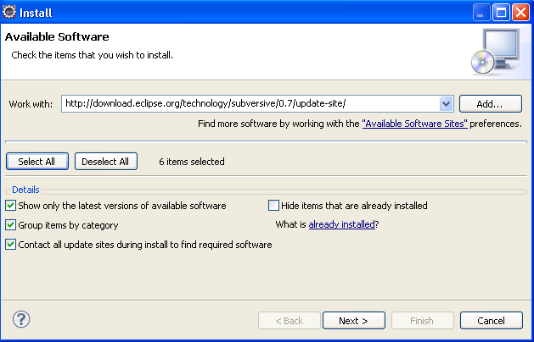
Click Select All, then Next
Next, Finish

Make sure Eclipse is pointed to a JDK rather than a JRE in Eclipse Preferences
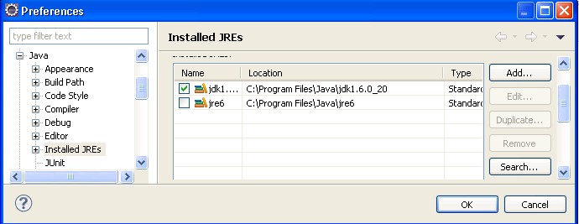

Set Eclipse Preferences for Subversion

Window → Preferences → Team → SVN

Menu icons → Tortoise SVN

Set up Server in Eclipse

New → Other → Server

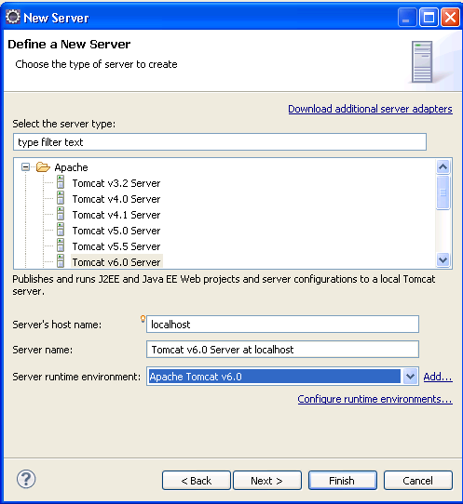

Next → Finish

Set Eclipse to use JDK instead of JRE

Add to C:\Program Files\eclipse\eclipse.ini

Per http://tech.karolzielinski.com/m2eclipse-eclipse-is-running-in-a-jre-but-a-jdk-is-required

E.g., -startup

plugins/org.eclipse.equinox.launcher_1.1.0.v20100507.jar

--launcher.library

plugins/org.eclipse.equinox.launcher.win32.win32.x86_1.1.0.v20100503

-product

org.eclipse.epp.package.jee.product

--launcher.defaultAction

openFile

--launcher.XXMaxPermSize

256M

-showsplash

org.eclipse.platform

--launcher.XXMaxPermSize

256m

--launcher.defaultAction

openFile

-vm

C:\Progra~1\Java\jdk1.6.0_20\jre\bin\javaw

-vmargs

-Dosgi.requiredJavaVersion=1.5

-Xms40m

-Xmx512m

Set Eclipse Preferences for Maven

Window → Preferences → Maven → Installations → Add → specify Maven root folder (e.g., C:\Program Files\Apache Software Foundation\apache-maven-2.2.1) → OK

Create a settings.xml file in location specified in Eclipse:

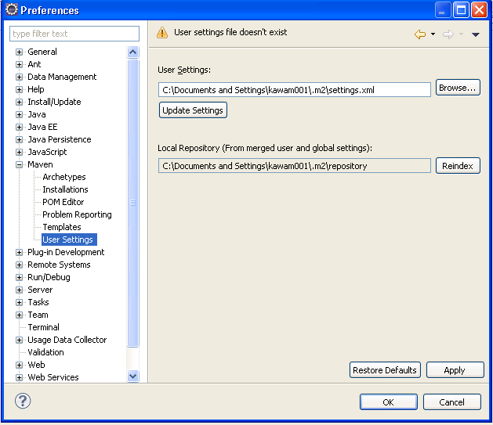

Sample XML
<settings xmlns="http://maven.apache.org/SETTINGS/1.0.0"
xmlns:xsi="http://www.w3.org/2001/XMLSchema-instance"
xsi:schemaLocation="http://maven.apache.org/SETTINGS/1.0.0
http://maven.apache.org/xsd/settings-1.0.0.xsd">
<localRepository>C:\Documents and Settings\ds187\.m2\repository</localRepository>
<interactiveMode/>
<usePluginRegistry/>
<offline/>
<pluginGroups/>
<servers/>
<mirrors>
<mirror>
<id>nexus</id>
<mirrorOf>*</mirrorOf>
<url>http://cfmdcisrv03.dhe.duke.edu:8081/nexus/content/groups/public</url>
</mirror>
</mirrors>
<proxies/>
<profiles>
<profile>
<id>nexus</id>
<repositories>
<repository>
<id>central</id>
<url>http://central</url>
<releases><enabled>true</enabled></releases>
<snapshots><enabled>true</enabled></snapshots>
</repository>
</repositories>
<pluginRepositories>
<pluginRepository>
<id>central</id>
<url>http://central</url>
<releases><enabled>true</enabled></releases>
<snapshots><enabled>true</enabled></snapshots>
</pluginRepository>
</pluginRepositories>
</profile>
</profiles>
<activeProfiles>
<activeProfile>nexus</activeProfile>
</activeProfiles>

</settings>

Setup Eclipse Servers

Tomcat
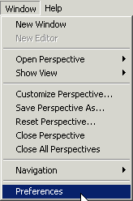
Choose Preferences from the Window menu

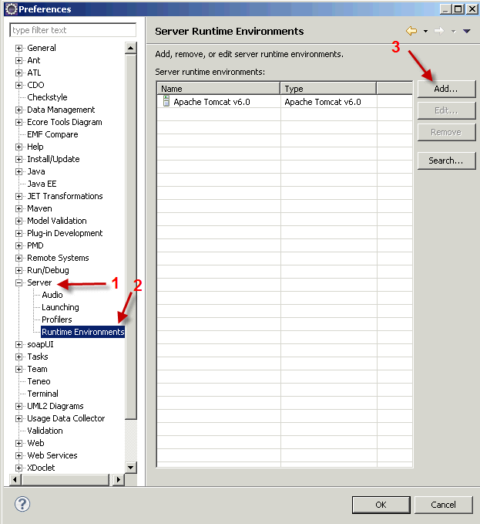
Add your Tomcat installation as shown above. Eclipse will automatically clone this Tomcat installation when you debug Web Services. You can add more than one instance of Tomcat (if you have configured more than one with different ports), or other containers such as JBoss or Sun Appserver or Weblogic…
At this point you are ready to import projects and use Eclipse!

OpenCDS Configuration in Eclipse

Import into Eclipse
All of the projects below are imported in the same way. The first one is a dependency for all the others. All of these projects are in Subversion, and they all implement some aspect of the OMG DSS spec.
- Dss-wsdl-v2-split
- Dss-sebastian-adapter
- Dss-isodynamic-warfarin-adapter
- Infobutton-kbschema
- Infobutton-schema
- Infobutton-service

Additional Subversion projects that you may be interested in include
- Drools (work in progress – see below)
- opencds-drools-service (work in progress)

Export the package from Subversion into C:\WorkJava (see below for alternate instructions using Eclipse directly, not Tortoise SVN)
I do this step using TortoiseSVN, but you can also do it within Eclipse. These directions assume you are doing it the way I do it, but there may be better approaches…
NOTE: Export from Subversion, then Import into Eclipse
In Windows Explorer, right click on c:\WorkJava folder and select TortoiseSVN | Export from the drop-down menu
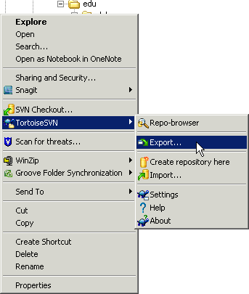
This will open a dialog giving you a chance to enter the repository location, and your local path. Use the following as base paths (or click on the buttons to search):
https://cfmdcisrv03.dhe.duke.edu/svn/CFMDCI/
C:\WorkJava
[If prompted, enter Duke ID and password]
For example, to export “dss-sebastian-adapter” from the repository to your local drive, you would use a TortoiseSVN Export window with these settings:
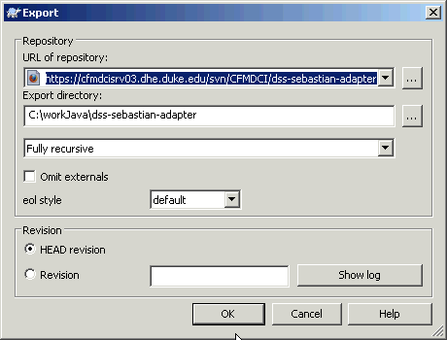

Export the package from Subversion into C:\Workjava using Eclipse (alternate instructions from above)

File → Import

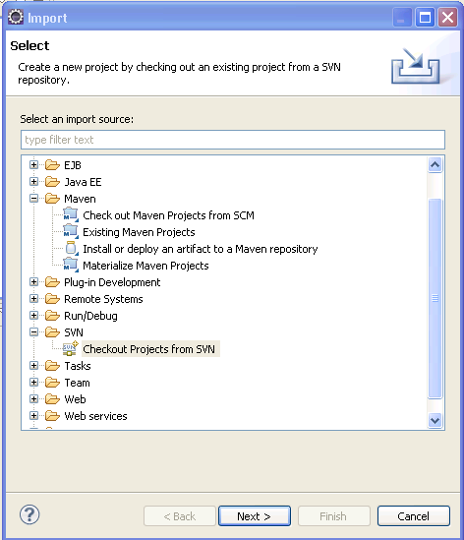

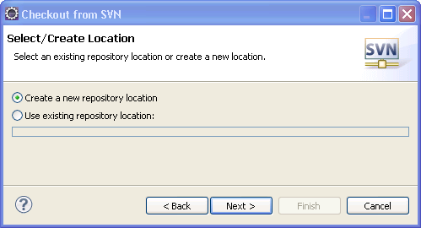

Set location of repository to https://Cfmdcisrv03.dhe.duke.edu/svn/CFMDCI

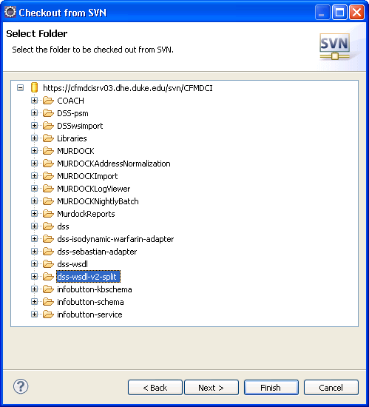

Next

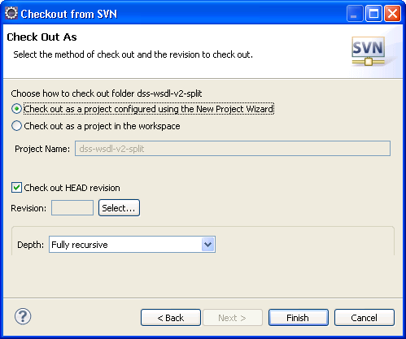

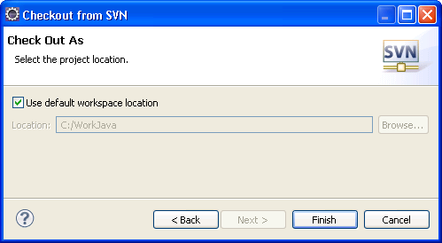

Import the project from C:\workJava into Eclipse
Go to the File \ Import menu in Eclipse:
Select “Import…” and you get this screen
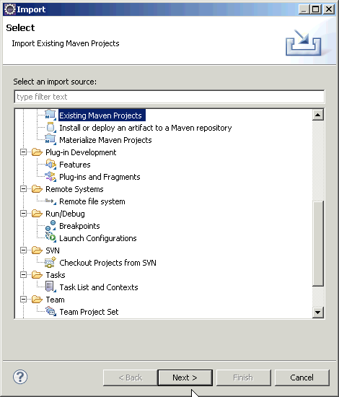
Make sure “Existing Maven Projects” is selected and click “Next”
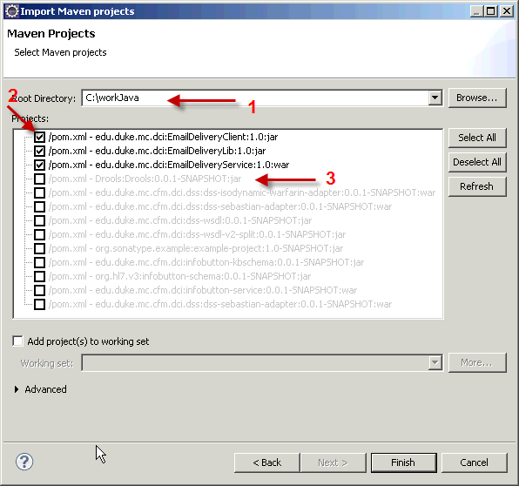
In the above window, set the “Root Directory” to “C:\workJava” (1) and Maven will go find all available projects in that directory. All available projects will be checked (2). Uncheck the ones you don’t want to import into Eclipse. Projects that have already been imported into Eclipse will be grayed out (3).
Note: If you want to clone an existing project to create a new variation on it, do that outside of Eclipse by copying the entire directory, and modify the Pom.xml file to reflect the new directory (project) name. Then import the new project into Eclipse as shown above.

Drools Configuration in Eclipse (coming)

Import into Eclipse

GreenCDA Mapper Configuration in Eclipse (coming)

Dependencies – Install first

Eclipse modeling tools

Install GreenCDA

Follow directions

Install CDA model

Install Sample Maps

